CS 340 README Template

GRAZIOSO SALVARE DASHBOARD

PROJECT

The Grazioso Salvare Dashboard is an interactive web application designed to track and analyze animal rescue data. The dashboard allows users to filter animal data based on different rescue types, such as Water Rescue, Mountain/Wilderness Rescue, and Disaster/Individual Tracking. The data is stored in a MongoDB database and includes information such as breed, age, sex, and location of animals.

By using various visual tools like pie charts and interactive maps, the dashboard offers an intuitive interface for users to explore animal rescue statistics. It integrates MongoDB for data storage, Python for backend operations, and Plotly Dash for front-end visualizations, providing a comprehensive solution for animal rescue organizations to make data-driven decisions.

MOTIVATION

The Grazioso Salvare Dashboard was developed to centralize animal rescue data in a user-friendly platform. The motivation behind this project is to simplify the tracking of animal rescues, helping users make informed decisions, improve resource management, and analyze trends across different rescue types. By providing insights into animal breeds, rescue operations, and their geographical distribution, the dashboard aims to contribute to more effective rescue efforts. Additionally, the project serves as an educational tool for understanding animal welfare and rescue operations, promoting data-driven approaches in animal rescue missions.

GETTING STARTED
Installation/Pre-Conditions
To get started with the Grazioso Salvare Dashboard, ensure the following tools are installed:
- MongoDB: A NoSQL database used to store the AAC dataset.
- Python 3.9 or higher: The programming language used for backend development.
- PyMongo: A Python driver to interact with MongoDB. To install PyMongo, run: pip install pymongo
- Plotly Dash and Dash Leaflet: Python libraries for building the web application and handling the interactive front end.
Ensure that Jupyter Notebook is also installed for testing purposes.

Setting up MongoDB
1. Import the AAC Dataset:
- Use the mongoimport tool to load the dataset into MongoDB.
- Import the file named aac_shelter_outcomes.csv into the AAC database and the animals collection.
- Use the credentials:
Username: aacuser
Password: Nikispring7

2. Clone the Project Repository:

- Clone the repository containing the CRUD Python Module and other necessary files for the project.

3. Testing the Module:
- Test the functionality of the CRUD Python module by running the provided Python scripts.
- Verify that the Create and Read operations work as expected, ensuring the data is properly inserted and retrieved from MongoDB.

PRODUCT WALKTHROUGH
The Grazioso Salvare Dashboard includes several key features to meet the needs of the organization:

Branding with Logo:
The dashboard incorporates the Grazioso Salvare logo to reflect the organization's identity.

Data Table with Custom Filters:
A dynamic data table displays the information of animals available at the Austin Animal Shelter. Custom filters allow users to refine the data based on specific rescue needs, including:

Water Rescue: Filter animals suitable for water rescue operations.
Mountain or Wilderness Rescue: Select animals trained for mountain or wilderness environments.
Disaster Rescue or Individual Tracking: Filter animals for disaster rescue or individual tracking.
Pie Chart:
A pie chart visualizes the breakdown of different dog breeds available at the shelter, helping to illustrate the distribution of animals by breed.

Interactive Map:
The dashboard includes an interactive map that displays the location of a selected animal, enabling users to see the geographical distribution of animals within the shelter.

The custom filters are configured based on the specifications provided by the client. For example, when selecting THE WATER RESCUE filter, you will see a pie chart displaying the breakdown of animal breeds, along with the geographical location of each animal. Additionally, you have the option to select multiple animals at once from each rescue category, and their locations will be displayed together on the map.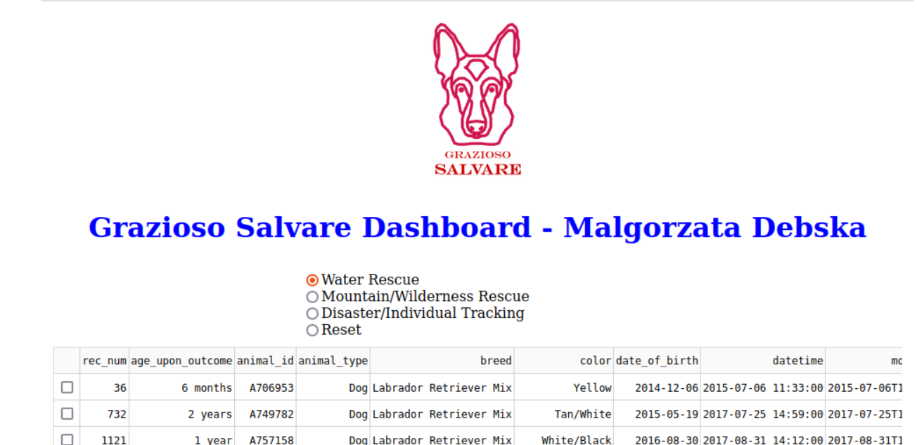

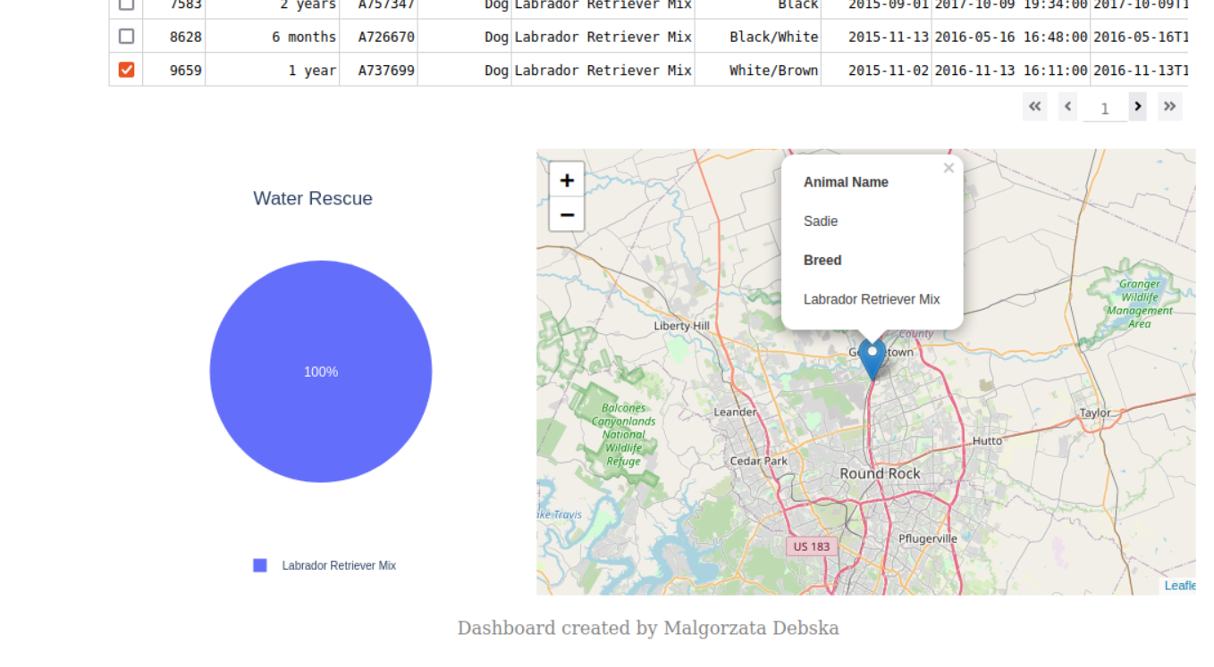

Here, we display the MOUNTAIN/WILDERNESS RESCUE:
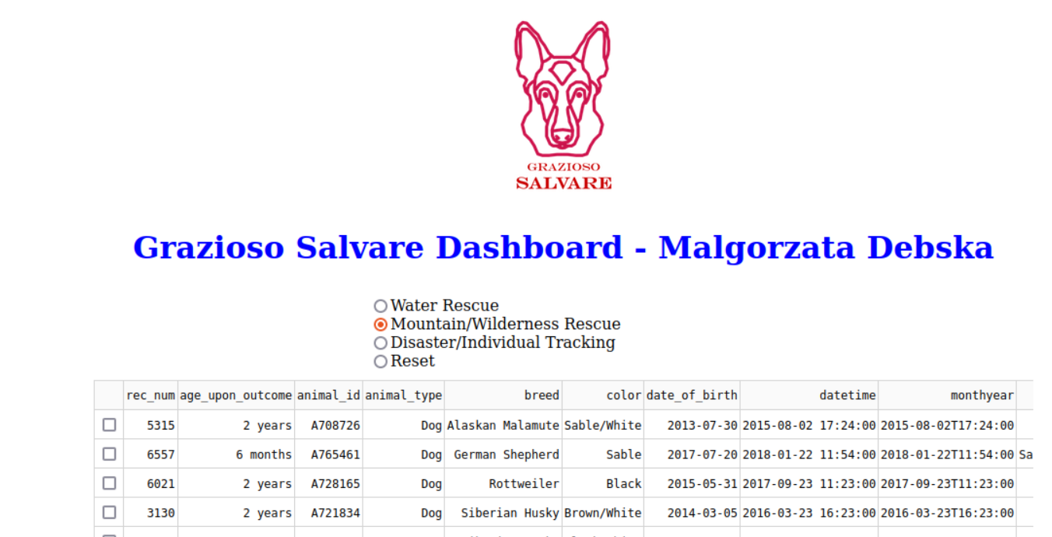

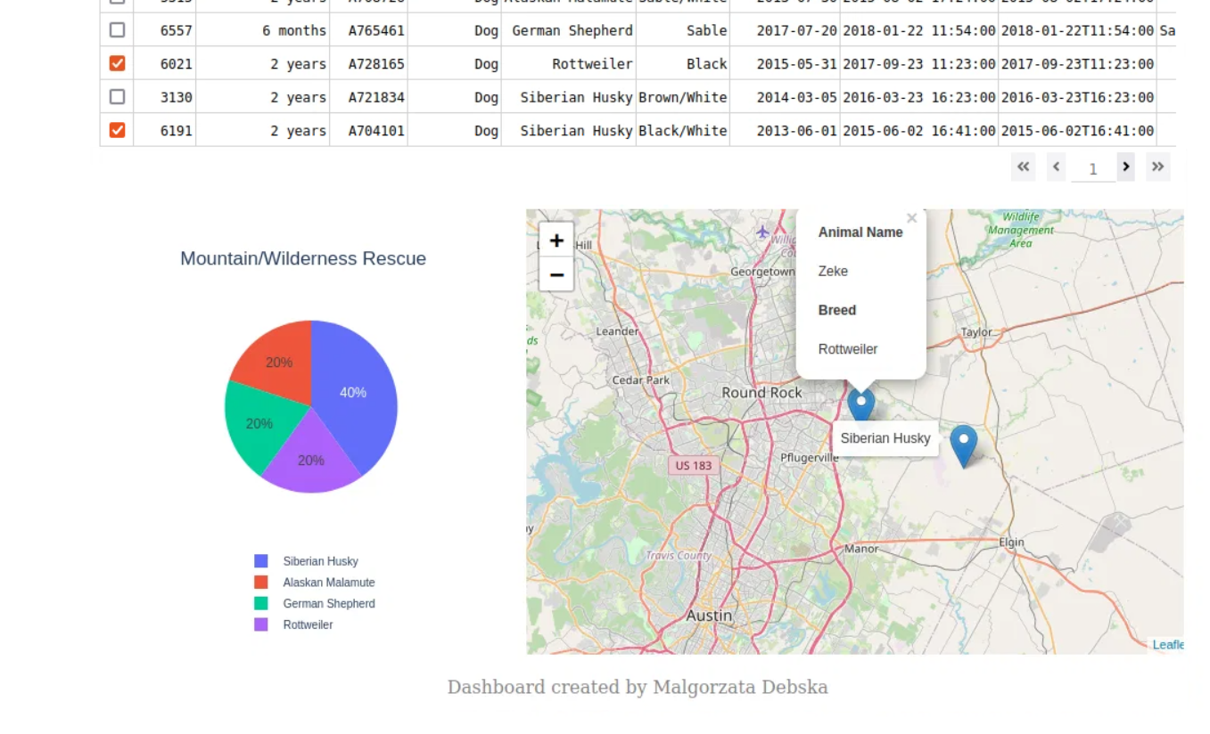

DISASTER INDIVIDUAL TRACKING rescue outcome:

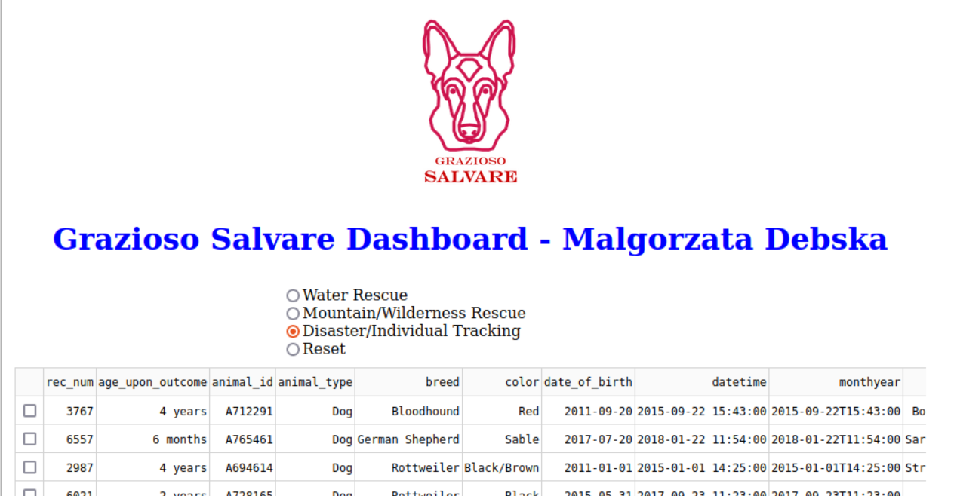

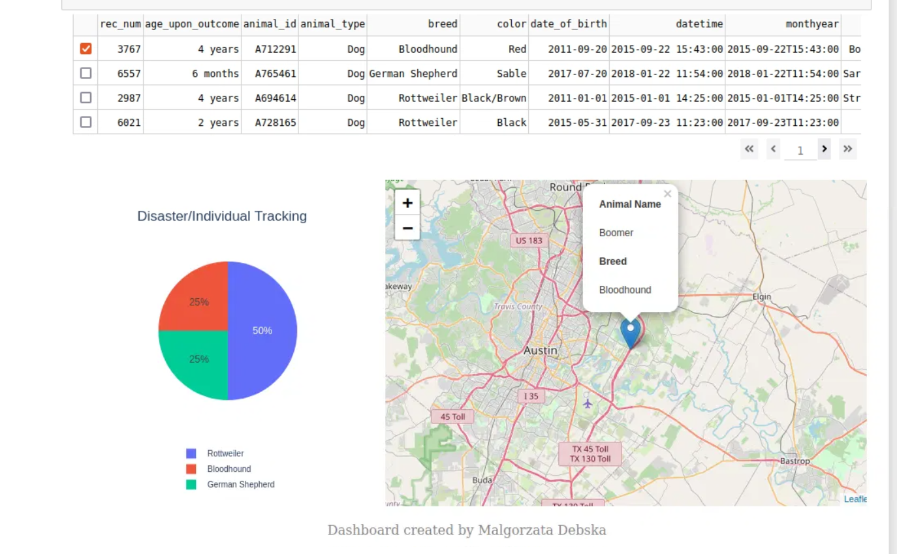

Finally, the RESET option displays all breeds:
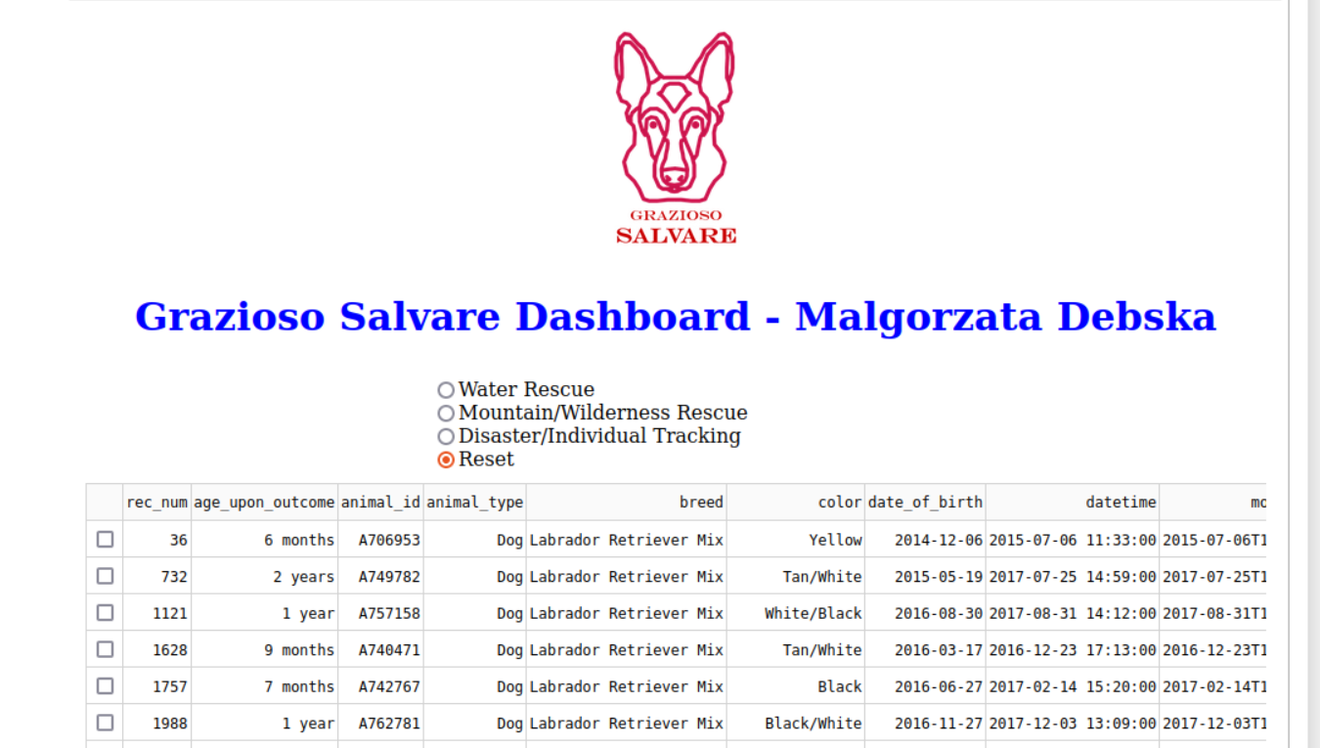

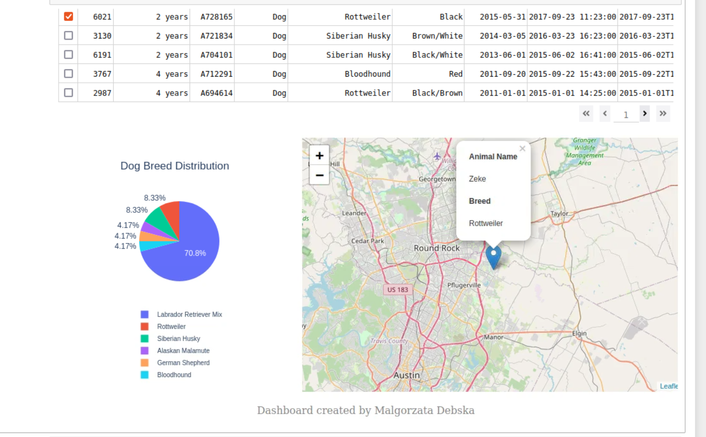

REBUILDING THE PROJECT
If the project needs to be recreated due to server migration or backup failure, follow these steps:

1. Install Required Components
Ensure the following tools are installed:
- MongoDB
- Python (version 3.9 or higher)
- PyMongo library (pip install pymongo)
- Plotly Dash and Dash Leaflet for front-end development
- Jupyter Notebook for testing the module
2. Load Data into MongoDB
- Use the mongoimport tool to load the dataset into MongoDB.
- Use an admin account to import the AAC dataset into the AAC database with the animal’s collection.
- Ensure MongoDB is running during this step.

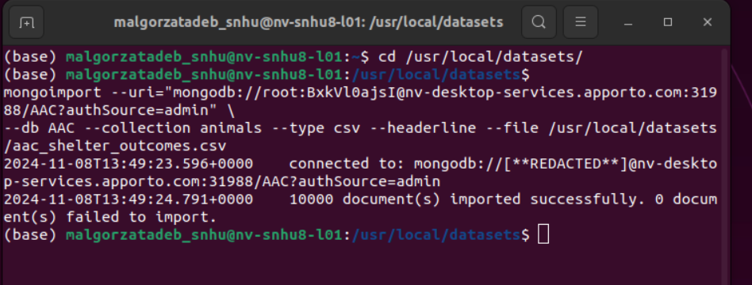

3. Create User Roles
- Create two user roles in MongoDB:
- Admin: Full access to the database.
- User: Read/write access to the database (required for CRUD operations).

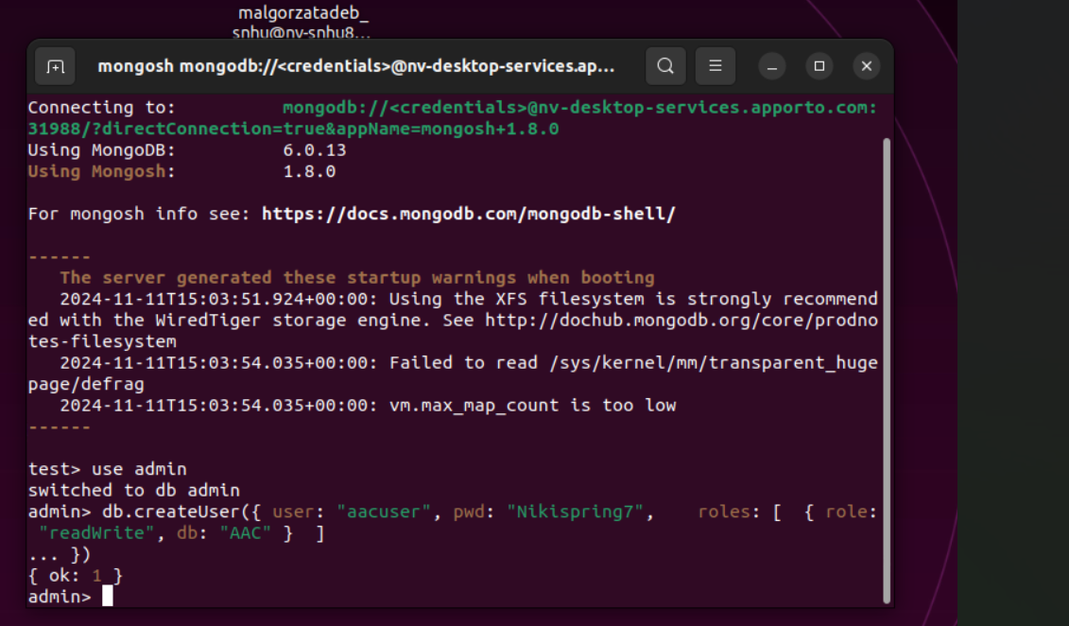

4. Add CRUD Class and Middleware-Dashboard Driver
- Deploy the CRUD class and the middleware-dashboard driver to the server.
- Update the driver with the username and password created for MongoDB access.

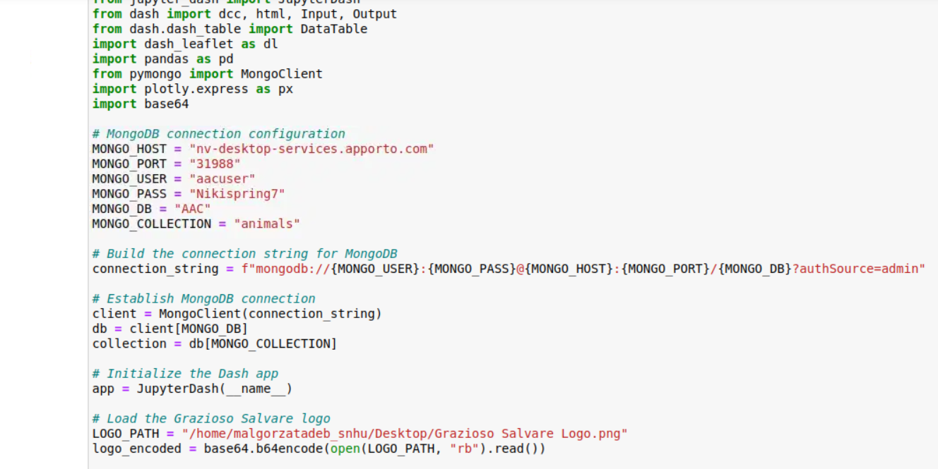

5. Add Dash Components and Callbacks
- Implement the necessary Dash components, such as the data table, pie chart, map, and radio buttons.
Example for data table:
dcc.DataTable(...)

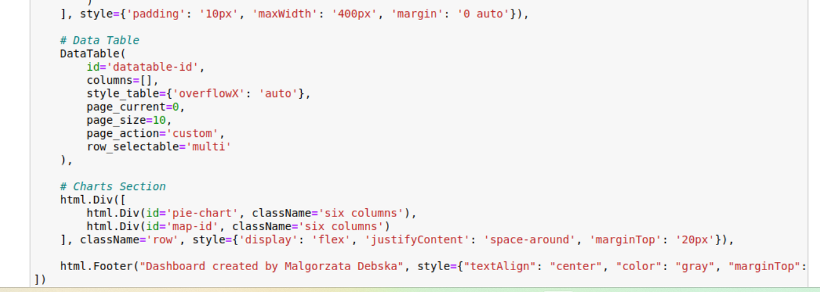

html.Div([...])

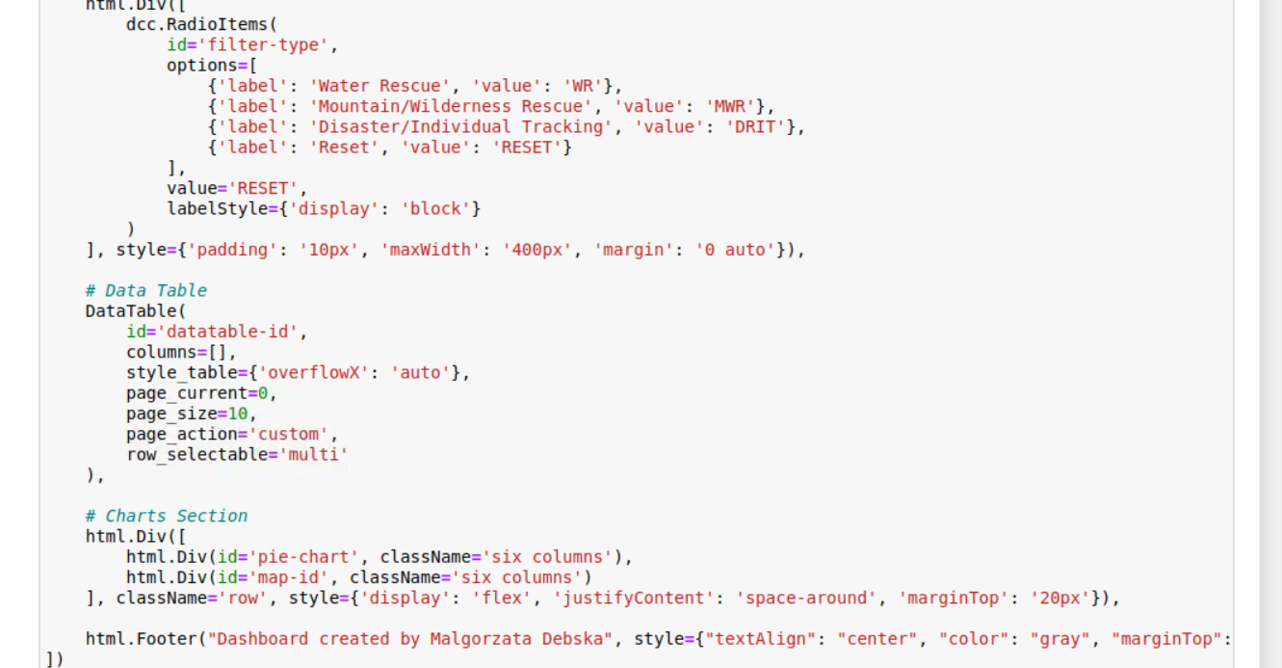

6. Update Filtering Criteria
- If needed, update any filtering criteria or regular expressions used to refine the data (e.g., Water Rescue filters).

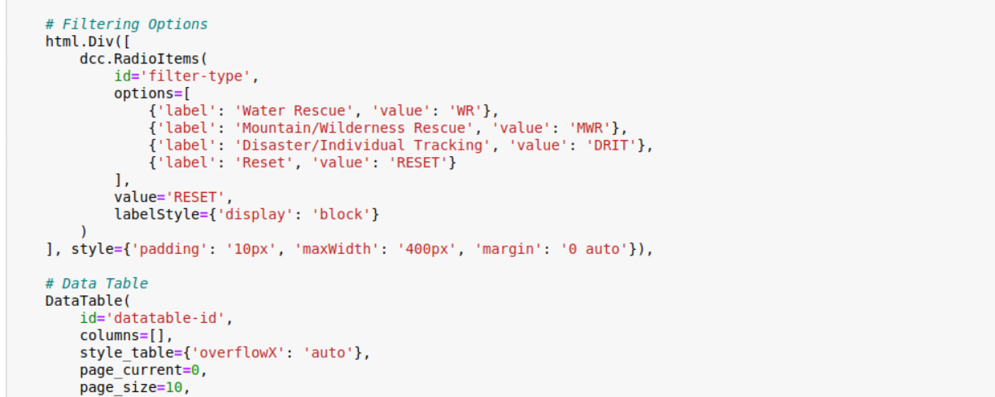

Logo and dashboard layout:
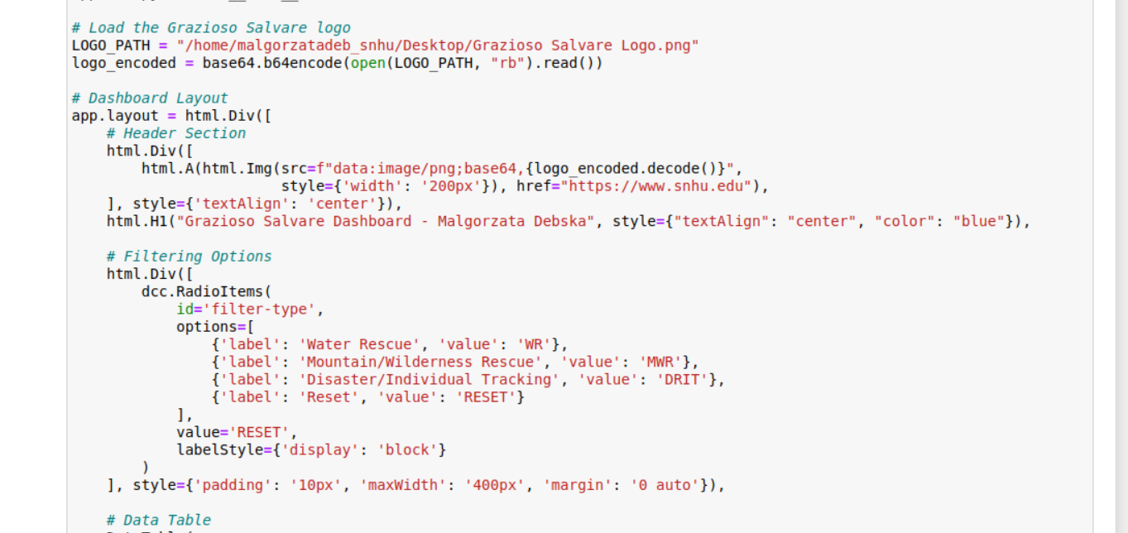

7. Start MongoDB
- Ensure MongoDB is running to provide access to the stored data.
8. Start the Python Middleware-Dashboard Driver
- Launch the Python script that runs the Dash web application and middleware.

ROADMAP & FEATURES
One of the most complex challenges was developing dynamic queries for filtering animals based on multiple attributes, such as rescue type, breed, and location. The complexity arose from the need to efficiently search through a large dataset with various conditions. Crafting these queries required careful planning to ensure they were flexible enough to handle various combinations of search criteria. To address this, we abstracted the query logic into reusable functions within the CRUD class, simplifying the process of creating and executing queries. Despite this, handling unexpected data formats and ensuring the filters worked as expected in all scenarios remained a key challenge throughout the development.

Another major challenge was integrating the interactive map to display the location of selected animals. Initially, the issue was ensuring that the map could display multiple animals at once without cluttering the interface. Synchronizing real-time updates between the data table and the map was also tricky, especially when users selected multiple animals at the same time. The solution involved creating dynamic Dash callbacks that updated the map each time a new animal was selected. However, fine-tuning the logic to handle multiple selections and ensure the map updated seamlessly required extensive testing and optimization to maintain performance while displaying accurate data for all selected animals.

Contact
For questions or further assistance, you can reach out to:
Name: Malgorzata Debska
Email: MalgorzataDebska@snhu.edu

